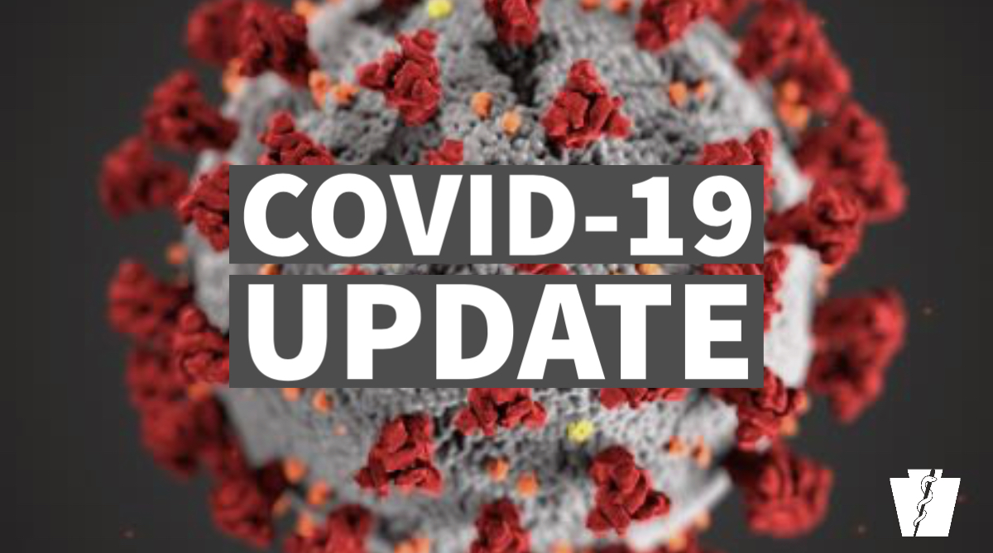

Lancaster Parking Authority (LPA) COVID-19 UPDATES
(as of March 17, 2020)

- NO meter/kiosk enforcement until further notice
- NO street cleaning and enforcement until further notice
- NO Residential Permit Parking (RPP) enforcement until further notice
- The Lancaster Parking Authority (LPA) Board of Directors March 26 meeting has been cancelled
- Park Your Butts Here event on March 18, 2020 has been cancelled (Scheduled to be held at the corner of W. Orange and N. Queen Sts., with partner Penn Medicine Lancaster General Health)
- LPA’s office is CLOSED to public
- Pay on website (TRANSACTION FEES WAIVED)
- Dropbox in office driveway
- By phone at 717-727-1908 (+transaction fee)
LPA Online Payment Options
- Online payments for parking violations, monthly parking, remittance slips and other invoices:
- On cells: Open lancasterparkingauthority.com, select “home” scroll to “pay online,” select payment type.
- On computers: Open lancasterparkingauthority.com, select “pay online," select payment type.
- Residential Permit Parking (RPP) applications and payments are available online at lancasterparkingauthority.com, select Residential Permit Parking, select option.
- Dropbox
- Check payments accepted via drop box at LPA office, 30 W. Orange St. Turn Left in driveway past office, drop box is on the side.
- Deposit payment in envelope with name, phone number, and payment type.
- Parking violation payments ONLY are accepted via phone at 717-727-1908. ($2.50 minimum service fee).
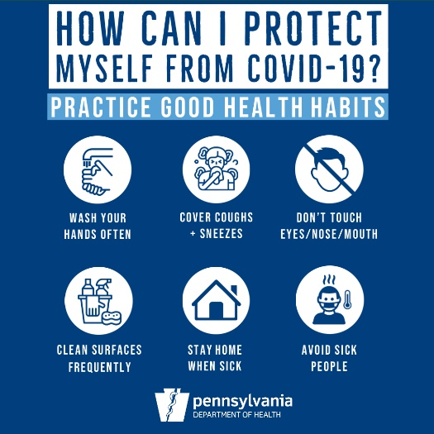

For more information on the novel coronavirus or COVID-19, please see:

- City of Lancaster Declares State of Emergency:
https://www.cityoflancasterpa.com/blog/city-of-lancaster-declares-state-of-emergency/

- Gov. Tom Wolf Declares Statewide Emergency:
https://www.governor.pa.gov/newsroom/gov-wolf-puts-statewide-covid-19-mitigation-efforts-in-effect-stresses-need-for-every-pennsylvanian-to-take-action-to-stop-the-spread/

- Commonwealth of Pennsylvania Information on COVID-19:
https://www.health.pa.gov/topics/disease/Pages/Coronavirus.aspx

- Centers for Disease Control (CDC) Guidance:
www.cdc.gov/COVID19

