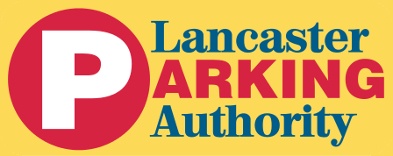

AGENDA

The regularly scheduled board meeting of The Lancaster Parking Authority will be held at 8:00 AM on Thursday, September 22, 2022. The meeting will be held in person at the LPA Administrative Offices at 30 West Orange Street, Lancaster, PA 17603.

The tentative agenda includes:

- Public Comment

- Approval of the August 25, 2022, Board Meeting Minutes

- Finance
  - Approval Minimum Municipal Obligation—Pennsylvania Municipal Retirement System
  - August 2022 Financial Reports
  - Christian Street Garage Project Cost Summary

- Economic Development
  - Update on Christian Street Garage project

